Project 2 Design Document

Chris Major

Tysen Radovich

Farshina Nazrul

Allen Simpson

September 26, 2019

Revision 1

|  |  |  |  |
| --- | --- | --- | --- |
| Date | Description | Revision | Editor |
| 09/26/2019 | Created Document | 0 | Allen Simpson |
|  |  |  |  |

# Contents

1. **Introduction 1** 
   1. Purpose 1
   2. Scope 1
   3. Definitions, Acronyms, Abbreviations 1
      1. Software 1
2. **Design Overview 1**
   1. Description of Problem 1
   2. Technologies Used 2
   3. System Architecture 2
   4. System Operation 2
3. **Requirements Traceability 3**
4. **Interface 1 3**
5. **Interface 2 6**
6. **Input Devices Subsystem 6**
7. **Data Model and Storage 7**
   1. Data_Storage 10
      1. Attributes 10
      2. Methods 10
   2. Data_Model 11
      1. Attributes 11
      2. Methods 11
8. **References 12**

1. **Introduction**
   1. **Purpose**

The purpose of this document is to describe the implementation of the TheraWii Software described in the TheraWii Business Requirements. The TheraWii Software is designed to create and perform physical therapy activities

* 1. **Scope**

This document describes the implementation details of the TheraWii Software. The software will consist of a two major functions. First to design therapies that are made up of tasks, and the second to perform the therapies. This document will not specify any actual therapies or the testing of the software.

* 1. **Definitions, Acronyms, Abbriviations**
     1. **Software**

**Therapy** A series of tasks that is completed in one session.

**Session** A given time in which a user completes a therapy.

**Task** A subunit of a therapy that has an objective with success and fail criteria.

A hole lot of Lorum Ipsum:

Lorem ipsum dolor sit amet, consectetur adipiscing elit. Fusce vitae augue feugiat, accumsan orci scelerisque, consectetur turpis. Nullam quis sapien congue, ultricies libero vel, consequat augue. Integer iaculis pulvinar facilisis. In placerat turpis nec est volutpat, id convallis quam molestie. Suspendisse tincidunt ac turpis a fringilla. In eu orci vulputate, tincidunt nibh et, tempus felis. Praesent mauris odio, cursus sit amet arcu nec, mattis sollicitudin nunc. Ut aliquam convallis posuere. Donec feugiat orci ac diam mollis suscipit. Phasellus tristique tellus id nibh semper egestas. Mauris suscipit, tortor at pretium feugiat, felis odio tristique felis, nec porta mi justo in orci.

Duis mattis accumsan ante non venenatis. Sed ultrices purus vitae erat sodales condimentum. Donec cursus tristique elit sed consequat. Donec vel arcu magna. Sed imperdiet orci et est rhoncus scelerisque. Etiam convallis leo sem, eget scelerisque mauris tempus et. Donec ac auctor risus.

Donec mauris metus, ultricies vel auctor eget, dapibus et massa. Vestibulum imperdiet auctor hendrerit. Praesent ultricies, leo eget consectetur placerat, nisi arcu dignissim nisl, maximus varius quam enim pharetra sem. Maecenas lacinia, massa pellentesque vehicula tempor, justo arcu pellentesque sem, aliquam laoreet neque enim at est.

1. **Design Overview**
   1. **Description of Problem**

Traditional physical therapy techniques are often limited to activities that provide little to no statistical feedback and technologies that provide this type of feedback are normally expensive. The TheraWii Software will use Nintendo Wii technology to provide physical therapists with data in an economical and eﬃcient approach.

* 1. **Technologies Used**

The TheraWii Software will communicate with input devices designed for the Nintendo Wii. The required devices include the Wii Balance Board, the Wii Remote, and the Wii Nunchuck. These devices will communicate with the software through Bluetooth wireless protocol. The target platform will be Microsoft Windows, and the development environment is Microsoft Visual Studio 2008. The therapies will be implemented in the Microsoft XNA game development framework.

* 1. **System Architecture**

Figure 1 depicts the high-level system architecture. The system will be constructed from multiple distinct components:

• Therapist Interface — The windowed interface for constructing and editing Therapies, and viewing or exporting proﬁles.

• Game Interface — The simple game-like environment for executing Therapies and collecting data. • Wii Library — The interface for maintaining Bluetooth connections to Wii input devices and generating input events.

• Data Model — The classes needed to organize Therapies, Tasks, Proﬁles, Sessions, etc.

• Data Storage — The interface for storing, importing and exporting the data model and raw collected data.

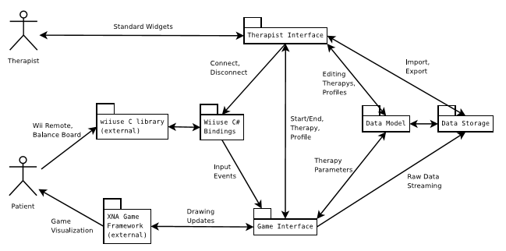

Figure 1: ThereWii Architecture

* 1. **System Operation**

Figure 2 is the typical sequence of events that occur during a TheraWii session.

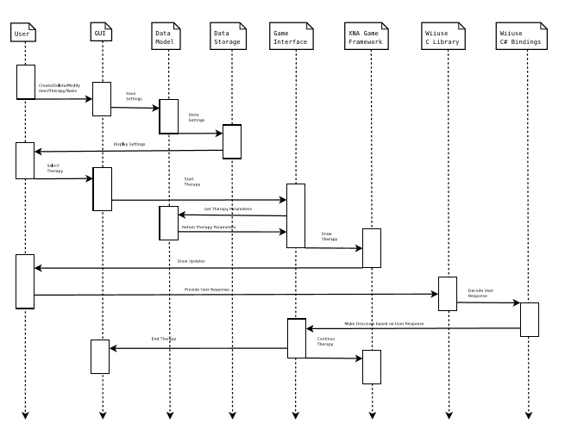

Figure 2:TheraWii Sequence Diagram

1. **Requirements Tracability**

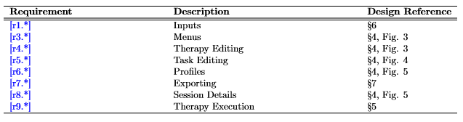

1. **Therapist Interface**

Figure 3 depicts the UML model for the Therapist Interface. Figure 4 depicts the UML model for each of the task editing forms. Figure 5 depicts the UML model for the Proﬁle interface. Most of the methods in these class diagrams represent callback functions for user input events.

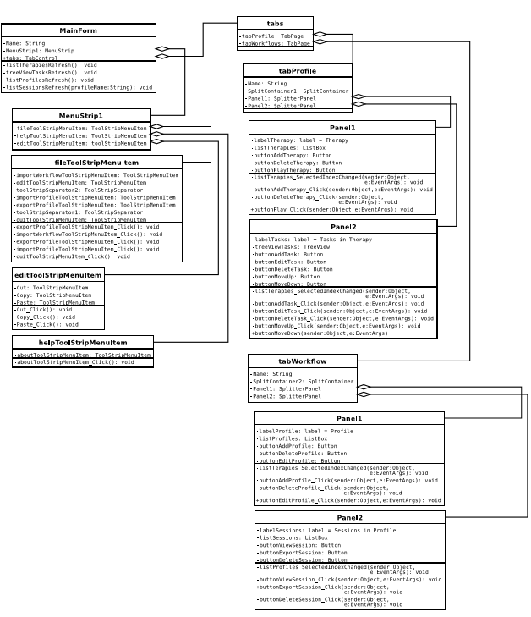

Figure 3: Main Therapist Interface

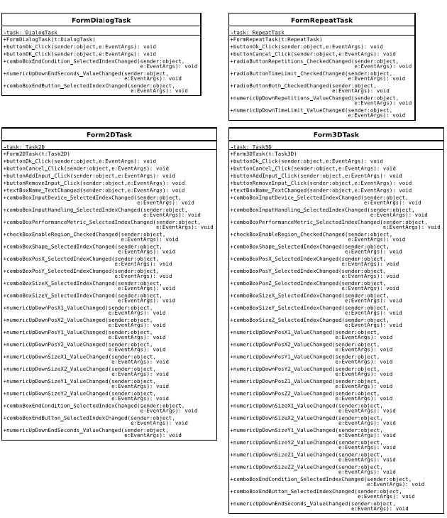

Figure 4:Task Editing Forums

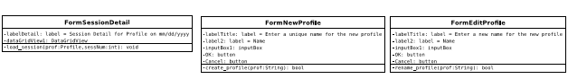

Figure 5: Profile Forms

1. **Game Interface**

Figure 6 depicts the UML model for the Game class.

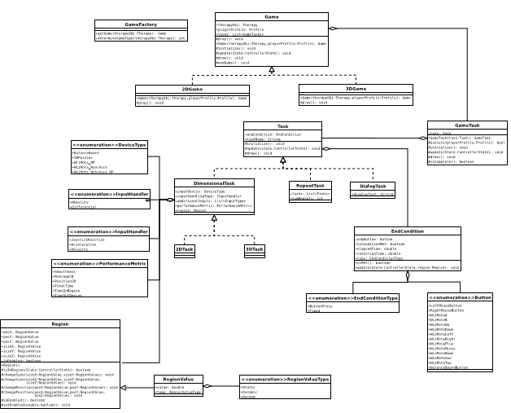

Figure 6: Game UML

1. **Input Devices Subsystem**

Figure 7 depicts the UML model for the WiiController Interface.

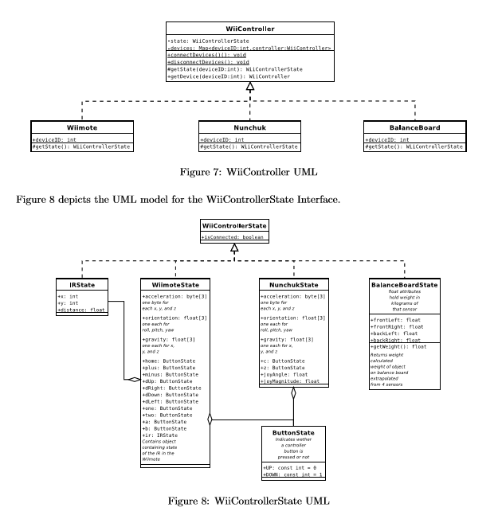

1. **Data Model and Storage**

The Data Model and Storage classes control loading and saving the proﬁle and therapy information. The Data Model holds the in-memory data while the Data_Storage class makes it possible to save the information in XML and CSV formats.

Figure 9 depicts the UML model for the Proﬁles/Sessions Data Model.

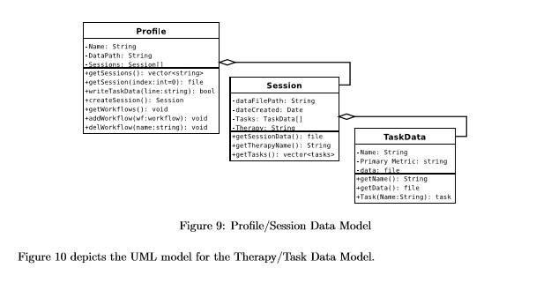

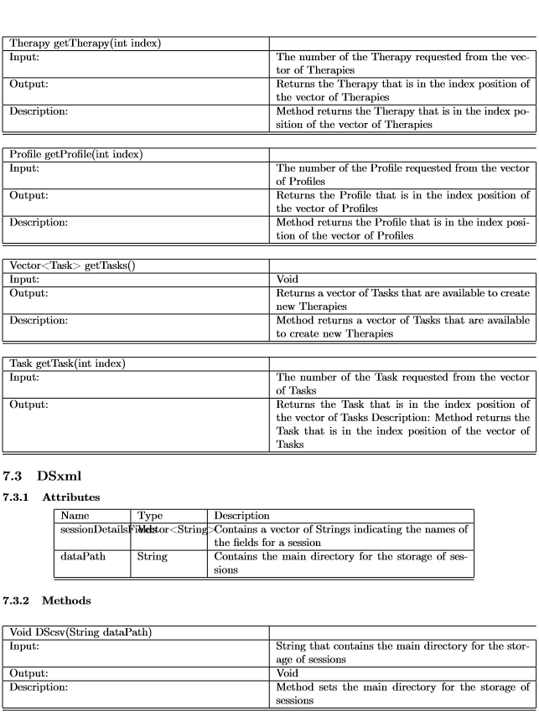

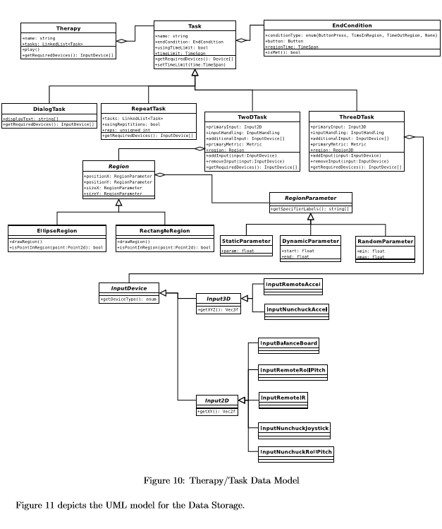

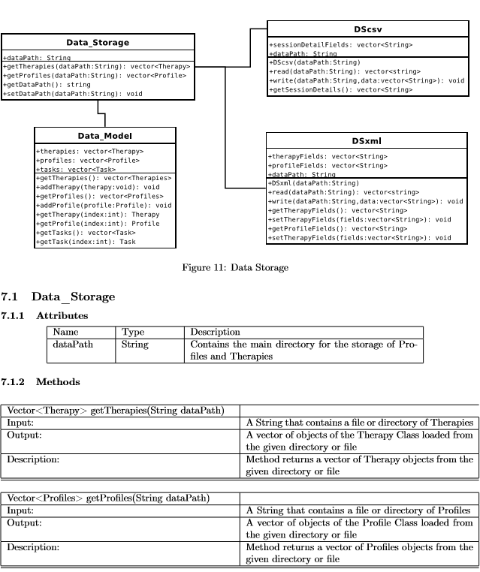

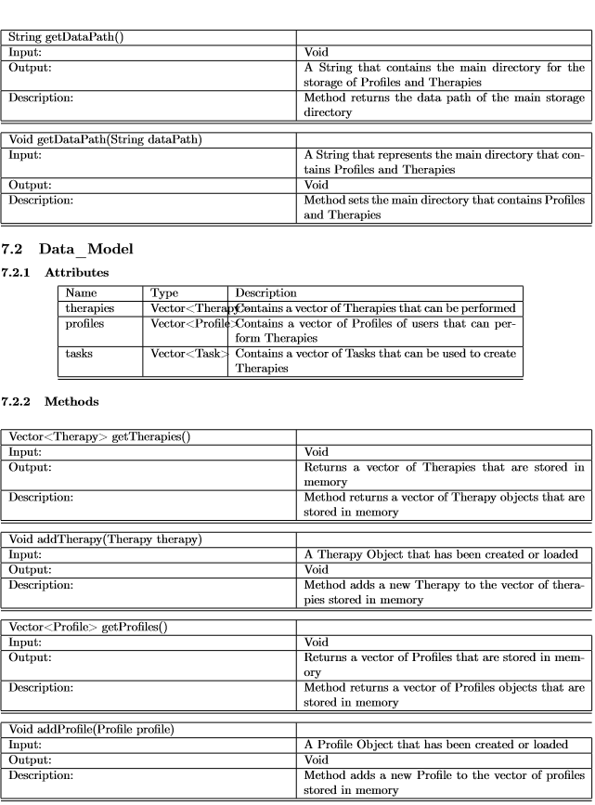

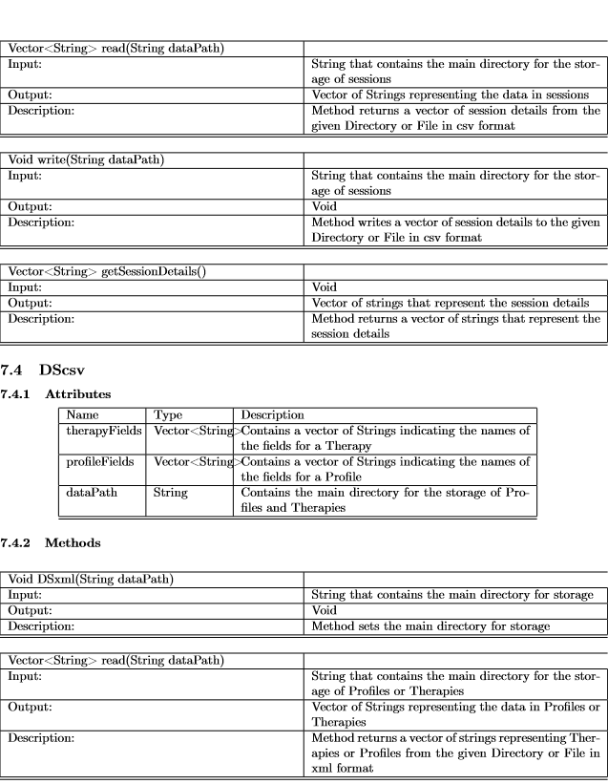

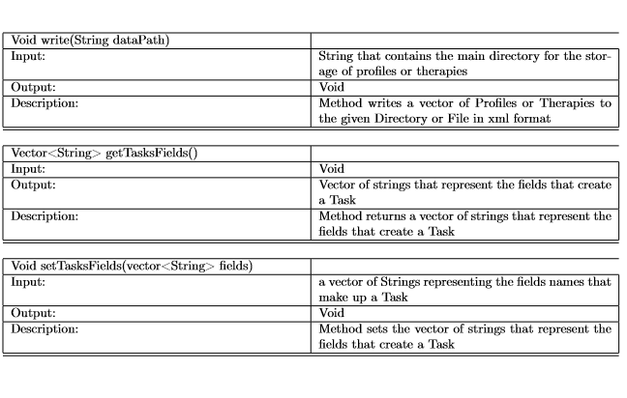

1. **References**

[JMLR Format]